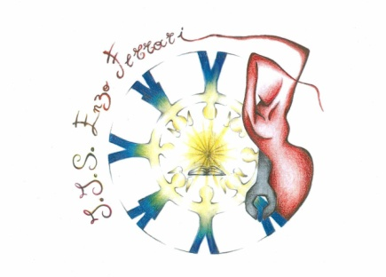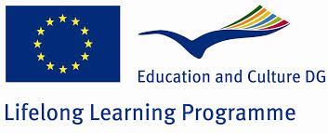

*Istituto di Istruzione Superiore Ministero*

*“Enzo Ferrari” della*

*Castellammare di Stabia Pubblica Istruzione*



**CERTIFICATE**

**This is to certify that the student Mutlu Dündar   has successfully attended the activity within the European Multilateral Comenius Project’s Meeting: “ I love my future as a European citizen ” that took place between 10th and 15th November in Italy, Castellammare di Stabia at the Istituto di Istruzione Superiore “ Enzo Ferrari ”.**

**Castellammare di Stabia, 15-11-2013**

**The Principal**

**Prof. Giuseppe Pecoraro**