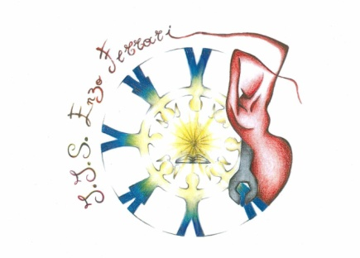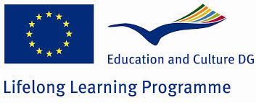

*Istituto di Istruzione Superiore Ministero*

*“Enzo Ferrari” della*

*Castellammare di Stabia Pubblica Istruzione*



**I.I.S. “ E. Ferrari” Castellammare di Stabia, 16/11/2013**

**Prot.2570/A9**

**To: Mr Andrzej Kotala**

**Miasto Chorzów**

**Subject:** Invitation to the first international teachers meeting

Project Comenius Multilateral School Partnership 2013/2015

**I LOVE MY FUTURE AS AN EUROPEAN CITIZEN**

Dear Mr. Kotala,

We are very pleased to invite you to the first international teachers meeting for Comenius Multilateral School Partnership 2013/2015 entitled “**I LOVE MY** **FUTURE AS AN EUROPEAN CITIZEN**” (Project number: 2013-1-TR1-COM06-48119-7)which will take place in Castellammare di Stabia between the dates 10th November and the 15th November.

For more information please find enclosed the agenda of the meeting.

**Yours Sincerely**

**Project Contact person Headmaster**

**Orsola Somma Giuseppe Pecoraro**