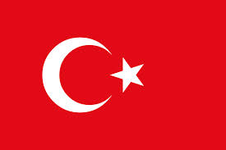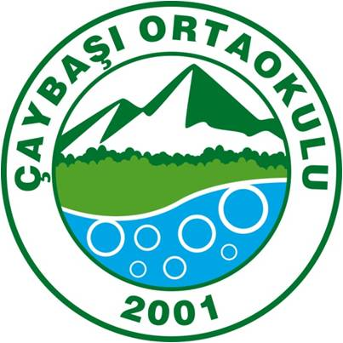
2013-2015 Comenius International Teacher’s Meeting Programme
BURSA -TURKEY
04/03/2015
09:00= Meeting in front of the hotel-
10:00-12:00= Arriving to Çaybaşı secondary school-wellcoming-students’ shows
12:30=Visits to ULUDAĞ mineral water factory-LUNCH THERE
14:00=Arriving to school,sport activities/coordinators meeting about project
16:00=Leaving school
17:00=Arriving to hotel
20:00= Dınner outside

05/03/2015
08:30: going Misi ( a village near lake)
10:00 Leaving Misi
10:30: Visiting automobile technical hıgh school
12:00 Bursa Grand bazaar
14:30 Irgandı bridge (Ottoman hand-craft art gallery-15.00 )
17:00 Arriving to hotel
19:00 Mudanya-the town near the Marmara sea-Bursa’s North border (city sightseeing-DINNER)
06/03/2015
Breakfast at the hotel
08:30 Meeting in front of the hotel
BURSA CITY TOUR:İnkaya big tree ,Murat hüdavendigar külliye ,Karagöz &Hacivat museum ,Atatürk’s house , Tophane, Ulucami-the biggest mosque, Yeşil mosque &tomb,Hünkar museum (LUNCH),Kent museum,Merinos industry and textile museum
18:00 Arriving the hotel
Free time

07/03/2015
09:30 Meeting in front of the hotel
10:30 Cumalıkızık (unesco heritage village&Ottoman houses)
12:00 arriving to hotel –free tıme for relaxing
16:30 leaving hotel for the Çaybaşı secondary school show programme
17:30-Show programme (FOLK DANCES-SEMA-MEHTER )
20:30 TURKISH NIGHT WITH FASIL (is a kind of popular Turkish music)-DINNER (Kıyı Alaturka restaurant

