FLAGS  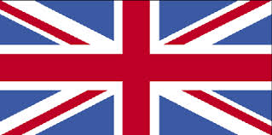 | 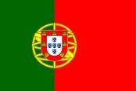 | 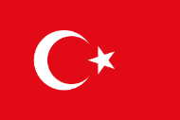 | 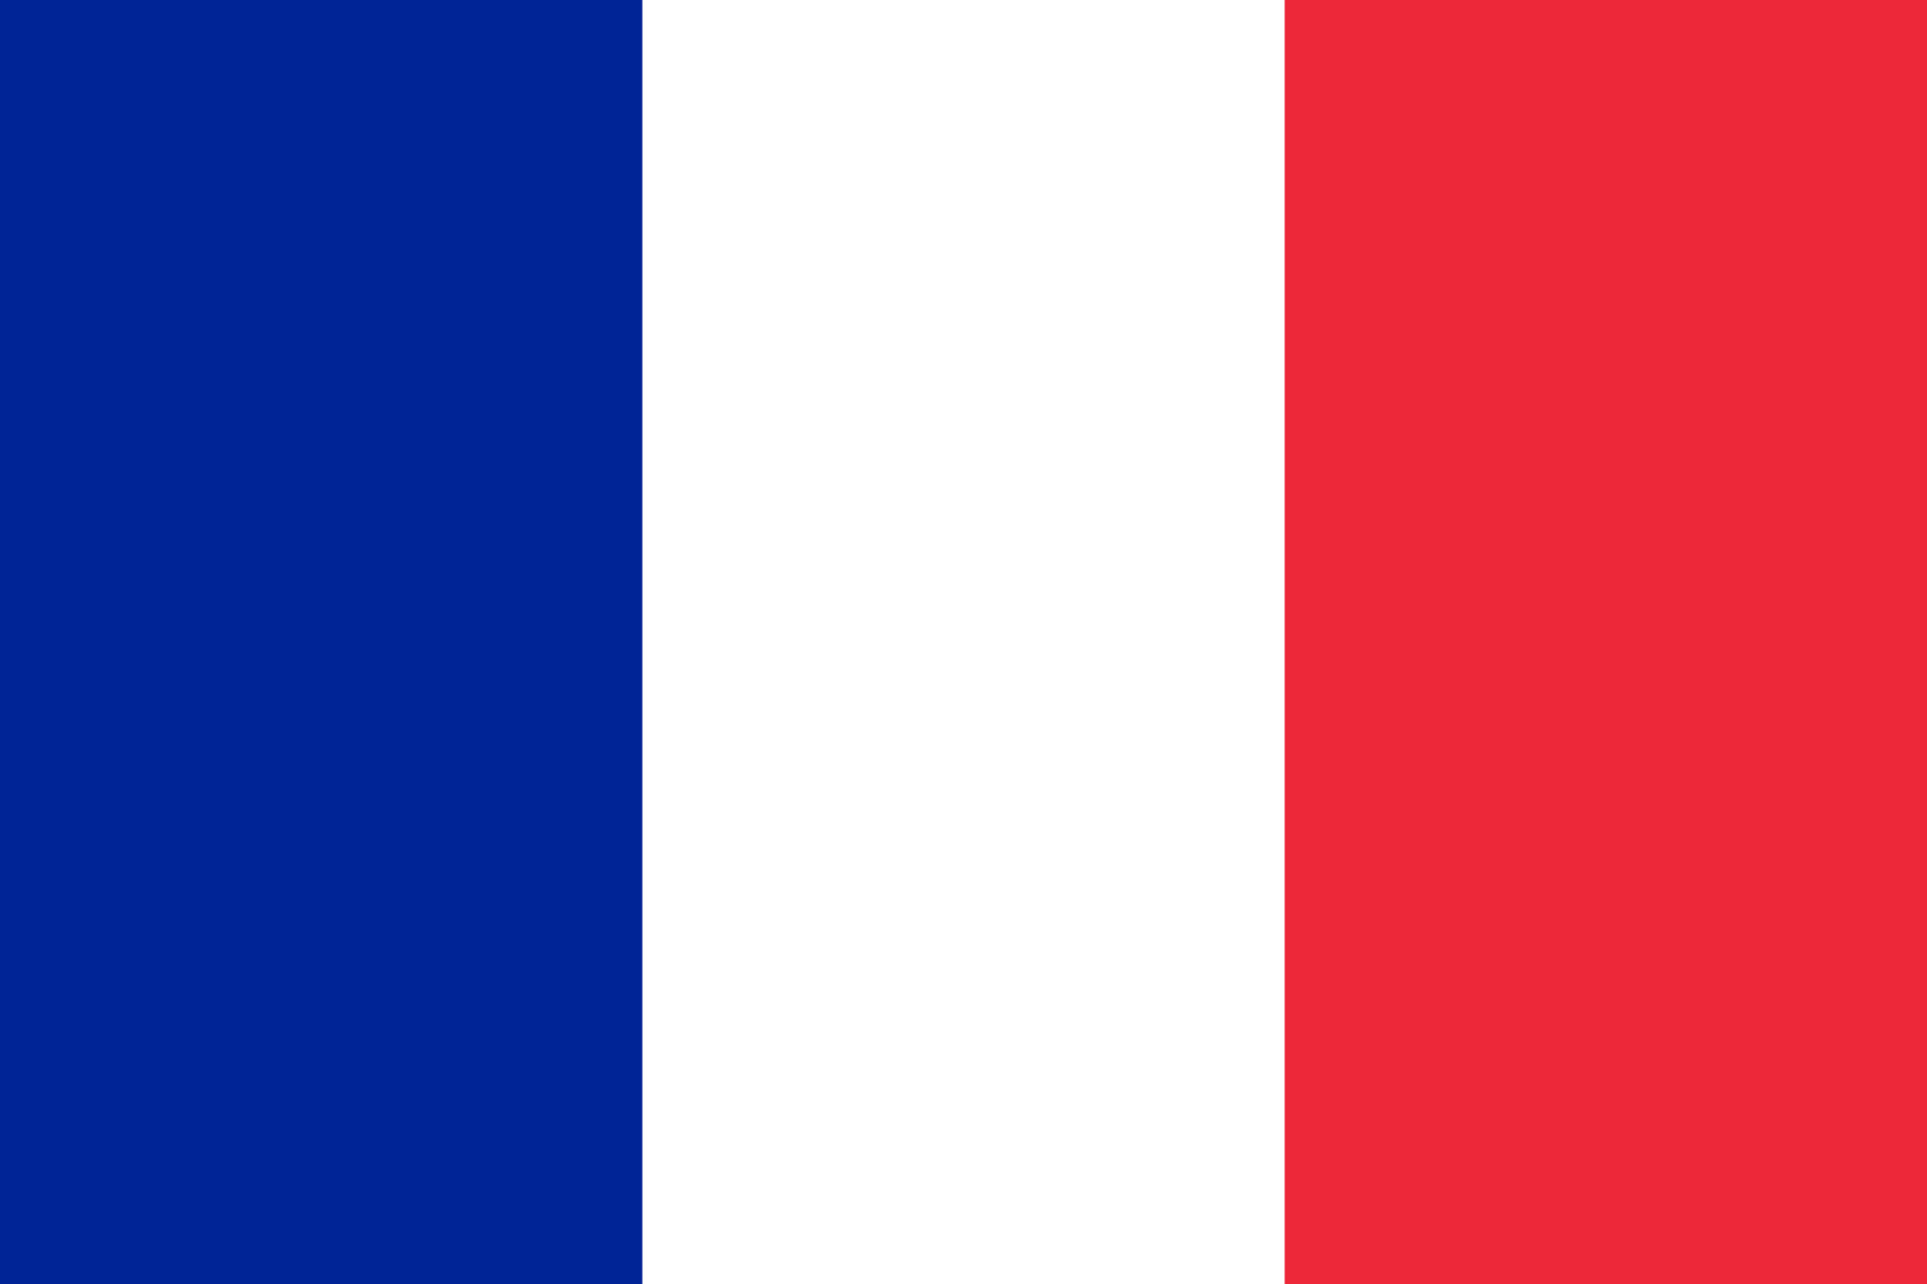 | 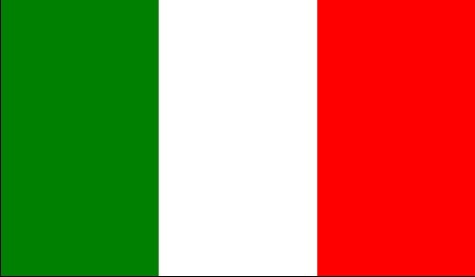 | 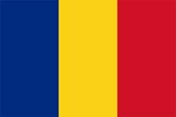 |  | 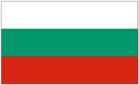
COUNTRY | PORTUGAL | TURKEY | FRANCE | ITALY | ROMANIA | POLAND | BULGARIA
NATIONALITY | PORTUGUESE | TURKISH | FRENCH | ITALIAN | ROMANIAN | POLISH | BULGARIAN
LANGUAGE | PORTUGUESE | TURKISH | FRENCH | ITALIAN | ROMANIAN | POLISH | BULGARIAN
CAPITAL CITY | LISBOA | ANKARA | PARIS | ROMA | BUCHAREST | WARSAW | SOFIA
TRADITIONAL  FOOD |  | KEBAP,BAKLAVA,  TURKISH DELIGHT |  | PASTA, PIZZA, MOZZARELLA,  POMODORI.  PROSCIUTTO |  |  | TARATOR, MUSAKA, SHOPSKA SALAD, BANITSA
HISTORICAL PLACES |  | TOPKAPI PALACE, HAGIA SOFIA, THE BLUE MOSQUE |  | CITTA’ DEL VATICANO, POMPEI, ERCOLANO, PAESTUM, AGRIGENTO, ROMA |  |  | ALEXANDER NEVSKI-MONUMENT, ST.SOFIQ-STATUE AND CHURCH, MONUMET OF VASIL LEVSKI
FAMOUS PEOPLE |  | ATATÜRK,MEVLANA,  MEHMET the CONQUEROR |  | Leonardo Da Vinci, Galileo Galilei, Giotto, Cristoforo Colombo, Botticelli, Giuseppe Garibaldi |  |  | VASIL LEVSKI, PAISII HILENDARSKI,  ST.ST.KIRIL I METODII
OUR COMENIUS PARTNERS AND INFORMATION ABOUT THEM

